Traductor de números a quechua

Esta programación esta en capas

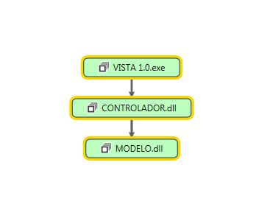

En la capa de modelo se tiene las clases de conexión

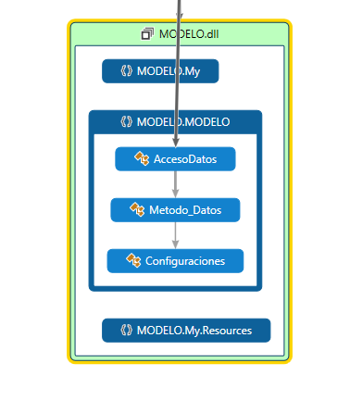

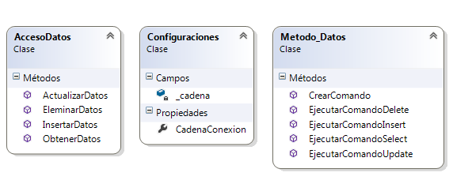

Capa de controlador

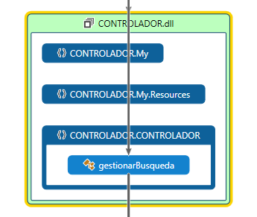

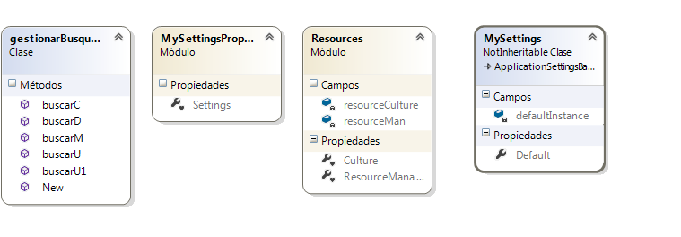

Capa de presentación o vista

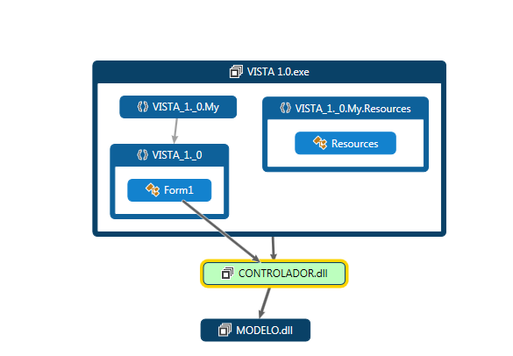

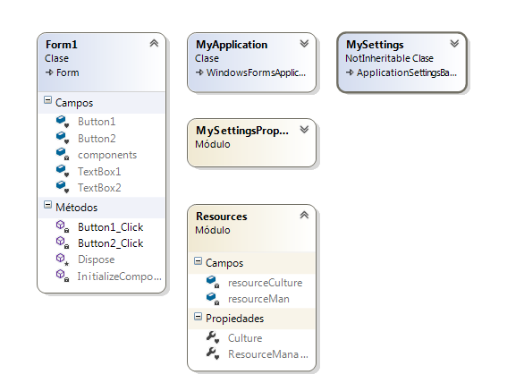

Diagrama no relacional de base de datos

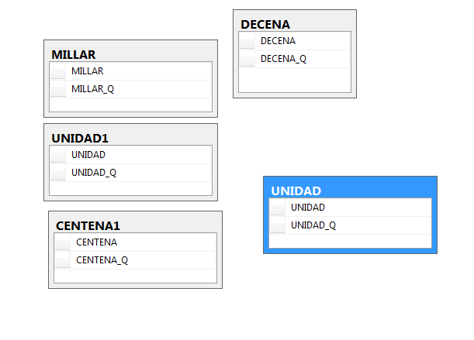

Script de la base de datos

USE [NUMERO]

GO

/****** Object: Table [dbo].[CENTENA1] Script Date: 24/07/2014 12:51:00 ******/

SET ANSI_NULLS ON

GO

SET QUOTED_IDENTIFIER ON

GO

CREATE TABLE [dbo].[CENTENA1](

[CENTENA] [int] IDENTITY(1,1) NOT NULL,

[CENTENA_Q] [nvarchar](100) NOT NULL

) ON [PRIMARY]

GO

/****** Object: Table [dbo].[DECENA] Script Date: 24/07/2014 12:51:01 ******/

SET ANSI_NULLS ON

GO

SET QUOTED_IDENTIFIER ON

GO

CREATE TABLE [dbo].[DECENA](

[DECENA] [int] IDENTITY(1,1) NOT NULL,

[DECENA_Q] [nvarchar](100) NOT NULL

) ON [PRIMARY]

GO

/****** Object: Table [dbo].[MILLAR] Script Date: 24/07/2014 12:51:01 ******/

SET ANSI_NULLS ON

GO

SET QUOTED_IDENTIFIER ON

GO

CREATE TABLE [dbo].[MILLAR](

[MILLAR] [int] IDENTITY(1,1) NOT NULL,

[MILLAR_Q] [nvarchar](100) NOT NULL

) ON [PRIMARY]

GO

/****** Object: Table [dbo].[UNIDAD] Script Date: 24/07/2014 12:51:01 ******/

SET ANSI_NULLS ON

GO

SET QUOTED_IDENTIFIER ON

GO

CREATE TABLE [dbo].[UNIDAD](

[UNIDAD] [int] IDENTITY(1,1) NOT NULL,

[UNIDAD_Q] [nvarchar](100) NOT NULL

) ON [PRIMARY]

GO

/****** Object: Table [dbo].[UNIDAD1] Script Date: 24/07/2014 12:51:01 ******/

SET ANSI_NULLS ON

GO

SET QUOTED_IDENTIFIER ON

GO

CREATE TABLE [dbo].[UNIDAD1](

[UNIDAD] [int] NOT NULL,

[UNIDAD_Q] [nvarchar](100) NOT NULL

) ON [PRIMARY]

GO

Código fuente del programa

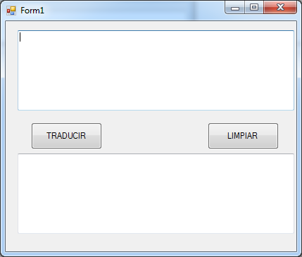

Código fuente

Imports MODELO.MODELO

Namespace CONTROLADOR

Public Class gestionarBusqueda

Public Sub New()

End Sub

Public Function buscarC(ByVal elemento As Long) As DataTable

Try

Dim accesodatos As New AccesoDatos

Dim sql As String

Dim tabla As DataTable

sql = "SELECT T.CENTENA_Q FROM CENTENA1 AS T WHERE T.CENTENA=" & elemento & ""

tabla = accesodatos.ObtenerDatos(sql)

Return tabla

Catch ex As Exception

Throw New Exception

End Try

End Function

Public Function buscarD(ByVal elemento As Long) As DataTable

Try

Dim accesodatos As New AccesoDatos

Dim sql As String

Dim tabla As DataTable

sql = "SELECT T.DECENA_Q FROM DECENA AS T WHERE T.DECENA=" & elemento & ""

tabla = accesodatos.ObtenerDatos(sql)

Return tabla

Catch ex As Exception

Throw New Exception

End Try

End Function

Public Function buscarM(ByVal elemento As Long) As DataTable

Try

Dim accesodatos As New AccesoDatos

Dim sql As String

Dim tabla As DataTable

sql = "SELECT T.MILLAR_Q FROM MILLAR AS T WHERE T.MILLAR=" & elemento & ""

tabla = accesodatos.ObtenerDatos(sql)

Return tabla

Catch ex As Exception

Throw New Exception

End Try

End Function

Public Function buscarU(ByVal elemento As Long) As DataTable

Try

Dim accesodatos As New AccesoDatos

Dim sql As String

Dim tabla As DataTable

sql = "SELECT T.UNIDAD_Q FROM UNIDAD AS T WHERE T.UNIDAD=" & elemento & ""

tabla = accesodatos.ObtenerDatos(sql)

Return tabla

Catch ex As Exception

Throw New Exception

End Try

End Function

Public Function buscarU1(ByVal elemento As Long) As DataTable

Try

Dim accesodatos As New AccesoDatos

Dim sql As String

Dim tabla As DataTable

sql = "SELECT T.UNIDAD_Q FROM UNIDAD1 AS T WHERE T.UNIDAD='" & elemento & "'"

tabla = accesodatos.ObtenerDatos(sql)

Return tabla

Catch ex As Exception

Throw New Exception

End Try

End Function

End Class

End Namespace

Namespace MODELO

Public Class Configuraciones

Dim _cadena As String = "Data Source=MENDEZ-PC;Initial Catalog=NUMERO;User ID=sistemas;Password=123" 'Integrated Security=true cuando se entra por la autentificacion de windows

Public ReadOnly Property CadenaConexion() As String 'propiedad de solo lectura

Get

Return _cadena

End Get

End Property

End Class

End Namespace

Imports System.Data

Imports System.Data.SqlClient

Namespace MODELO

Public Class AccesoDatos

Public Function ObtenerDatos(ByVal sql As String) As DataTable

Dim mDatos As New Metodo_Datos

Dim oComando As SqlCommand = mDatos.CrearComando

Try

oComando.CommandText = sql 'falta hacer todavia aqui

Return mDatos.EjecutarComandoSelect(oComando)

Catch ex As Exception

Throw New Exception

Finally

oComando.Connection.Close()

End Try

End Function

Public Function InsertarDatos(ByVal sql As String) As Boolean

Dim mDatos As New Metodo_Datos

Dim oComando As SqlCommand = mDatos.CrearComando

Try

oComando.CommandText = sql

Return mDatos.EjecutarComandoInsert(oComando)

Catch ex As Exception

Throw New Exception

Finally

oComando.Connection.Close()

End Try

End Function

Public Function ActualizarDatos(ByVal sql As String) As Boolean

Dim mDatos As New Metodo_Datos

Dim oComando As SqlCommand = mDatos.CrearComando

Try

oComando.CommandText = sql

Return mDatos.EjecutarComandoUpdate(oComando)

Catch ex As Exception

Throw New Exception

Finally

oComando.Connection.Close()

End Try

End Function

Function EleminarDatos(ByVal sql As String) As Boolean

Dim mDatos As New Metodo_Datos

Dim oComando As SqlCommand = mDatos.CrearComando

Try

oComando.CommandText = sql

Return mDatos.EjecutarComandoDelete(oComando)

Catch ex As Exception

Throw New Exception

Finally

oComando.Connection.Close()

End Try

End Function

End Class

End Namespace

Imports System.Data

Imports System.Data.SqlClient

Namespace MODELO

Public Class Metodo_Datos

Public Function CrearComando() As SqlCommand

Dim config As New Configuraciones

Dim _cadenaConexion As String = config.CadenaConexion

Dim oConexion As New SqlConnection

oConexion.ConnectionString = _cadenaConexion

Dim oComando As New SqlCommand

oComando = oConexion.CreateCommand

oComando.CommandType = CommandType.Text

Return oComando

End Function

Public Function EjecutarComandoSelect(ByVal oComando As SqlCommand) As DataTable

Dim oTabla As New DataTable

Try

oComando.Connection.Open()

Dim oAdapter As New SqlDataAdapter

oAdapter.SelectCommand = oComando

oAdapter.Fill(oTabla)

Catch ex As Exception

Throw New Exception

Finally

oComando.Connection.Close()

End Try

Return oTabla

End Function

Public Function EjecutarComandoInsert(ByVal oComando As SqlCommand) As Boolean

Dim resp As Boolean = False

Try

oComando.Connection.Open()

Dim oAdapter As New SqlDataAdapter

oAdapter.SelectCommand = oComando

If oComando.ExecuteNonQuery > 0 Then

resp = True

Else

resp = False

End If

Catch ex As Exception

Throw New Exception

Finally

oComando.Connection.Close()

End Try

Return resp

End Function

Public Function EjecutarComandoUpdate(ByVal oComando As SqlCommand) As Boolean

Dim resp As Boolean = False

Try

oComando.Connection.Open()

Dim oAdapter As New SqlDataAdapter

oAdapter.SelectCommand = oComando

If oComando.ExecuteNonQuery > 0 Then

resp = True

Else

resp = False

End If

Catch ex As Exception

Throw New Exception

Finally

oComando.Connection.Close()

End Try

Return resp

End Function

Public Function EjecutarComandoDelete(ByVal oComando As SqlCommand) As Boolean

Dim resp As Boolean = False

Try

oComando.Connection.Open()

Dim oAdapter As New SqlDataAdapter

oAdapter.SelectCommand = oComando

If oComando.ExecuteNonQuery > 0 Then

resp = True

Else

resp = False

End If

Catch ex As Exception

Throw New Exception

Finally

oComando.Connection.Close()

End Try

Return resp

End Function

End Class

End Namespace

Imports CONTROLADOR.CONTROLADOR

Public Class Form1

Private Sub Button1_Click(sender As Object, e As EventArgs) Handles Button1.Click

Dim n, m, c, d, u As Long

Dim t, t1, t2, t3 As DataTable

Dim R As String

Dim g As New gestionarBusqueda

n = CLng(TextBox1.Text)

R = " "

If n >= 10 And n < 10000 Then

m = n \ 1000

n = n Mod 1000

c = n \ 100

n = n Mod 100

d = n \ 10

u = n Mod 10

If m > 0 Then

t = g.buscarM(m)

R = t.Rows(0)("MILLAR_Q")

End If

If c > 0 Then

t1 = g.buscarC(c)

R = R & " " & t1.Rows(0)("CENTENA_Q")

End If

If d > 0 Then

t2 = g.buscarD(d)

R = R & " " & t2.Rows(0)("DECENA_Q")

End If

If u > 0 Then

t3 = g.buscarU1(u)

R = R & " " & t3.Rows(0)("UNIDAD_Q")

End If

TextBox2.Text = R

ElseIf n > 0 And n < 10 Then

t3 = g.buscarU(n)

R = R & " " & t3.Rows(0)("UNIDAD_Q")

TextBox2.Text = R

ElseIf n < 0 And n >= 10000 Then

R = "limpia y intruduce otro ..... no existe..."

TextBox2.Text = R

End If

End Sub

Private Sub Button2_Click(sender As Object, e As EventArgs) Handles Button2.Click

TextBox1.Text = ""

TextBox2.Text = ""

End Sub

End Class